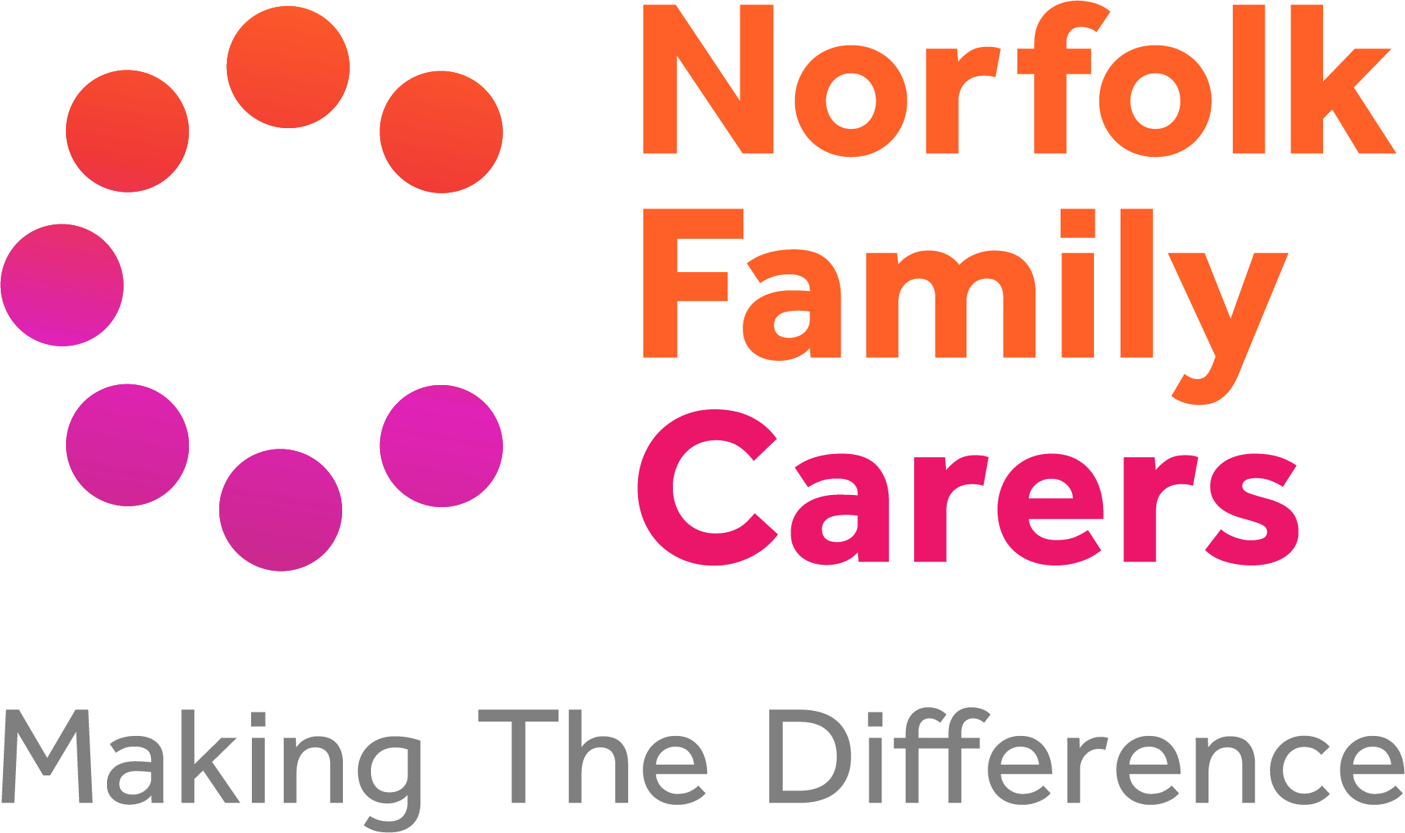


Global’s Make Some Noise
Young Carers Family Break
Application Form

Section 1: Family details

Details of those attending the Family Break
Name | Date of Birth | Young  Carer? | Address:
Home telephone no:

Mobile telephone no:

Email:

Are you aware of any risks to our staff when we visit the home? |  |  |  | Yes |  | No
If yes, please provide details

Section 2: Details of caring role

Person needing care
Name: |  |  |  |  | Date of Birth:
Relationship to Young Carer/s:

Conditions
Mental Ill Health |  | Chronic/Severe Illness |  | Physical Disability
Learning Difficulty |  | Drug/Alcohol/Gambling Problems |  | Sensory Impairment
Other (please state)

Type of caring being provided by Young Carer/s
Emotional support to the cared for & other family members
Household tasks i.e. shopping and cleaning
Personal care i.e. washing/dressing/bathing/toileting
Help with siblings
Helping with finances i.e. working to bring in money for the household
Interpreting for cared for- signing/other communication
Other (please give details)

Impact caring has on Young Carer/s:

Section 3: Family Break details

Need
When did the family last have a short break or holiday?

What is the families total annual income? | £
How does the family feel this break will help them in their current situation?:

When and where would the family like to take their break?:

Please tell us of any special requirements needed during their break e.g. disabled access:

Are the family able to provide their own transport to and from the break? |  | Yes |  | No

Section 4: Referrer details

Referred by
Name: | Date:
Organisation and relationship to family: | Address:
Telephone: | Email address:
Please tell us why you feel that the family need a break and how they will benefit from it?:

Are Childrens Services working with the family? (Please tick as appropriate):
Family Support Process (FSP) in place
Child in Need (subject to Section 17)
Child Protection (subject to Section 47)
Other statutory intervention (please specify):

Please give name and contact details of your social worker or support worker:

Other Agencies Involved: (e.g Families Unit, NSFT, Matthew Project)
Workers Name | Agency | Contact Details

Referrer’signature…………………………………………………………………….Date…………………

Section 5: Declaration
I confirm that the information given in this application is correct.
I understand I may need to provide additional information in support of this application.
I understand that if my application is successful I will:
- Commit to attending the Family Break and complete a pre and post Family Break questionnaire form
- Provide my own transport to and from the Family Break location.
I am aware that I can only receive one Family Break within a 2 year period.

Parent Signature …………………………………………………………………… Date………………….

Information sharing
The information contained in this form will be securely stored on Norfolk Family Carers’ database adhering to GDPR regulations. Your information will be used for the purpose of arranging the Family Break with the holiday provider but will not be shared more widely without the consent of the Young Adult Carer and/or the parent(s)/guardian(s) as appropriate. However, information may be shared more widely (without consent) where there is a risk of harm to the Young Adult Carer and/or others.

Section 6: Equality monitoring
This information is used for monitoring purposes only.
Please tick the boxes that the Young Carer identifies with.

Ethnicity
White (British/ Irish) |  | Black British |  | Indian
White European |  | Black African |  | Pakistani
White other |  | Black other |  | Chinese
Other Ethnic group |  | Gypsy or Traveller |  | Mixed/ Dual background
Does not wish to share
Religion
Christian |  | Muslim |  | Jewish
Buddaism |  | Hindu |  | None
Sikh |  | Does not wish to share
Disability
Physical Disability |  | Chronic/Severe Illness |  | Terminal illness
Mental Ill Health |  | Drug/Alcohol/Gambling Problems |  | None
Learning Difficulty |  | Does not wish to share
Sexual Orientation
Heterosexual |  | Homosexual |  | Other
Bisexual |  | Lesbian |  | Does not wish to share
Gender
Male |  | Female |  | Does not wish to share
Other (Please state)

Please contact us on 01603 219924 if you have any difficulty filling in this form.

Please complete & post to Young Carers Family Break Norfolk Family Carers First Floor, 36 St Giles Street Norwich
NR2 1LL

Or email to info@norfolkfamilycarers.org

If you would like more information on services provided by Norfolk Family Carers, please go to www.norfolkfamilycarers.org.

